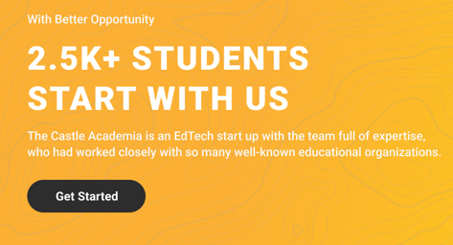

2.5K + students had a kickstart career with us

**"IF IT SCARES YOU, IT MIGHT BE A GOOD THING TO TRY "**

The Castle Academia is an EdTech start up with the team full of expertise who had worked closely with IIT Bombay, IIT Madras,IIT Kanpur, IIT Kharagpur IIT Roorkee, BITS Pilani, NITs & 20+ colleges national wide.

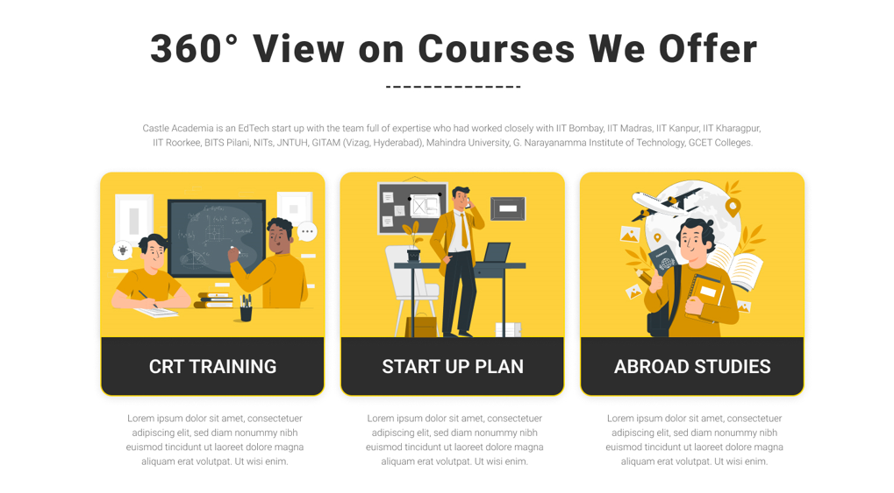

**HEADING**

* The most crucial component of career transition is determining which professional route is meant for you and receiving expert's advice on that track.

**Under crt card**

Learn core industry skills from top edtech instructors.We assist in hunting new job opportunities and our expertise helps you land on dream job through mentoring in networking, interviewing, and placement techniques.

**Under startup plan card**

We personally assist & modify plan according to your ideation followed by building startup from scratch to seed funding which includes leadership management ,pitch and product readiness, 1:1 session with CEO's.

**Under abroad studies card**

" ***Discover and interact with Alumni of your dream college who once travelled the same route as you***. "

We provide A-Z overseas services, from assisting you in selecting the best university to enrolling in it.

Exam and Career Guidance

GRE/GMAT/IELTS/TOEFL prep

College shortlisting

LOR,SOP service

Visa counselling

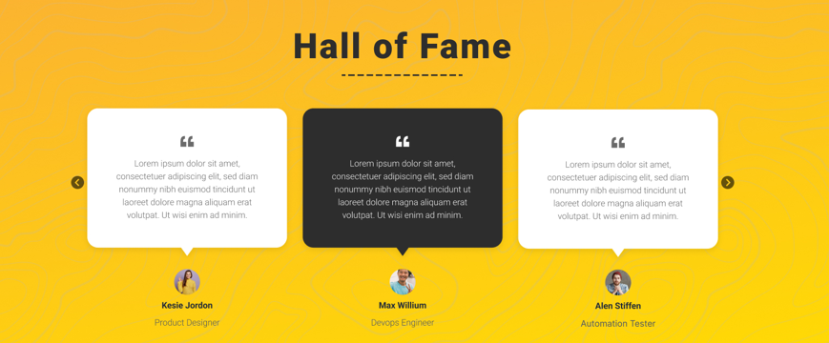

1st comment

Name - Naman jain

It's been a pleasure learning with Castle Academia. It was extremely beneficial to me in terms of affordable education. Thank you, Castle Academia.

2nd comment

Name - Pratik ojha

Castle Academia's course is extremely well-structured. I would suggest anyone looking to get started with a decent product-based firm then look into Castle Academia.

3rd comment

Name - sushma naik

I've always wanted to establish a business, and this platform not only helped me understand the startup ecosystem but also allowed me to communicate closely with the founders and chairs of well-known startups.

4th comment

Name - Ajay roy

Thank you so much, Castle Academia! I was enrolled to my favourite university, Arizona State University, and received 50% of my scholarship thanks to the assistance of your overseas team.

5th Comment

Name - Preeti shah

I learned how to create a startup within budget with the help of this platform.

6th Comment

Name - Preeti Dixit

Overall I enjoyed the way of teaching where mentor explained untill we get the concept

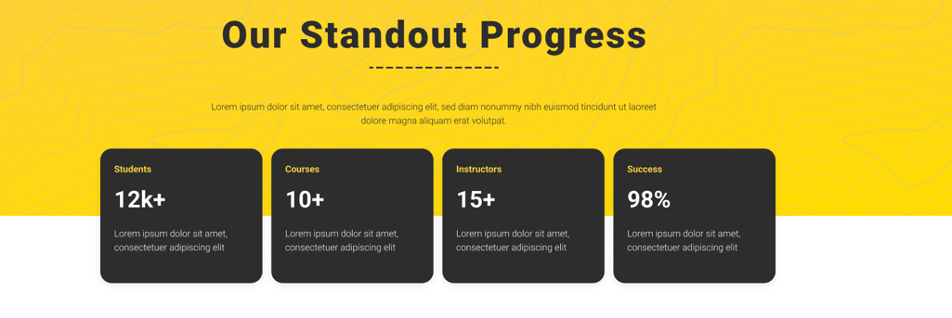

**Remove the heading of the above cards**

STUDENTS (2.5K +)

Number of students successfully enrolled

Courses ( 10+ )

We provide a wide range of more than 10+ courses that cater to the interests of each individual student in the class.

Instructors (200 +)

We have top-tier professionals experts who hold no less than 15+ years of experience in the respective field